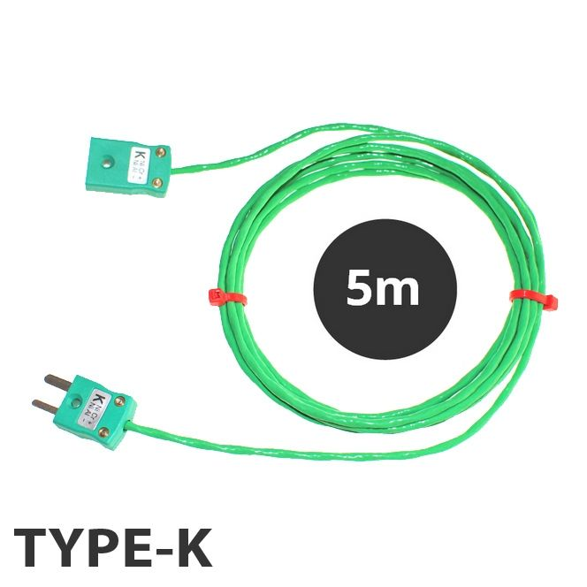

**Type K PFA Thermocouple Extension Leads with Miniature Plug & Socket (IEC) – 5m**

XE-7047-001

Labfacility are the UK’s leading manufacturer of Temperature Sensors, Thermocouple Connectors and associated Temperature Instrumentation and stockists of Thermocouple Cables. The Company has been trading since 1971 and is ISO 9001 accredited.

**Specifications**

|  |  |
| --- | --- |
| **General Description** | Resistant to oils, acids other adverse agents and fluids. Good mechanical strength and flexibility. PTFE better for steam/elevated pressure environments. |
| **Cable Length** | 5M |
| **Cable Type** | Conductors PFA insulated and twisted together, stainless steel braided screen, overall PFA sheath |
| **Connector Size** | Miniature |
| **Core / Strands** | 7/0.2mm |
| **Conductor Cross Section 7/0.2 (mm2)** | 0.219 |
| **Outer Colour** | Green |
| **+ Colour** | Green |
| **- Colour** | White |
| **Drain Wire** | No |
| **Insulation Material** | PFA Insulated |
| **Loop Resistance 7/0.2 (Ohms per combined metre)** | 4.5 |
| **Max. Temperature** | 260°C |
| **Min. Temperature** | -75°C |
| **+ Conductor** | Nickel Chromium |
| **- Conductor** | Nickel Aluminium |
| **Screen** | Yes |
| **Screen Type** | Stainless Steel Braided |
| **Standards Met** | Colour code (cores & jacket) to IEC-584-3 |
| **Thermocouple Type** | K |
| **Termination Type** | Miniature Thermocouple Plug |
| **Tolerance** | Class 1 |

**Ordering Information**

|  |  |  |  |
| --- | --- | --- | --- |
| **Type** | **Length** | **Termination** | **Order Number** |
| K | 5m | Miniature Plug & Socket | XE-7047-001 |