**Miniature Thermocouple Connector Plug**

**AM-J-M Type J ANSI**

XE-9060-001

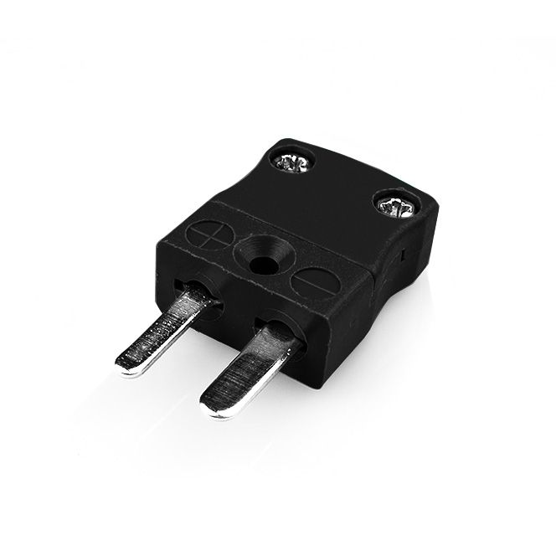

Labfacility are the UK’s leading manufacturer of Temperature Sensors, Thermocouple Connectors and associated Temperature Instrumentation and stockists of Thermocouple Cables. The Company has been trading since 1971 and is ISO 9001 accredited.

**Specifications**

|  |  |
| --- | --- |
| **General Description** | Ideal for general purpose use. Contacts are polarised to ensure correct connection. |
| **Thermocouple Type** | J ANSI |
| **Connector Type** | Plug |
| **Connector Size** | Miniature |
| **Colour** | Black |
| **Max. Temperature** | 220°C |
| **Pins** | Flat Pins |
| **+Positive Contact** | Iron |
| **-Negative Contact** | Copper Nickel |
| **Standards Met** | BS EN 50212:1997. RoHS |

**Ordering Information**

|  |  |  |  |
| --- | --- | --- | --- |
| **Thermocouple Type** | **Colour Code** | **Type** | **Order Number** |
| J | ANSI | Plug | XE-9060-001 |

