**Hermetically Sealed Wire RTD Sensor – 2m**

XE-6381-001

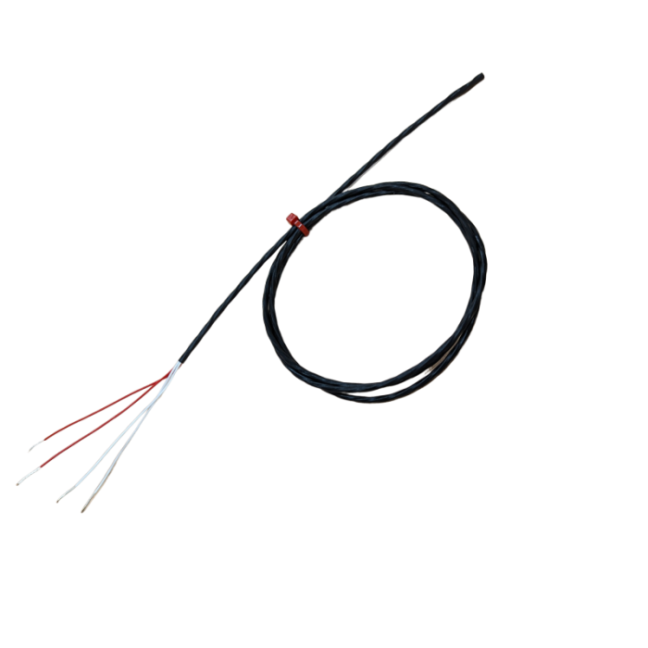

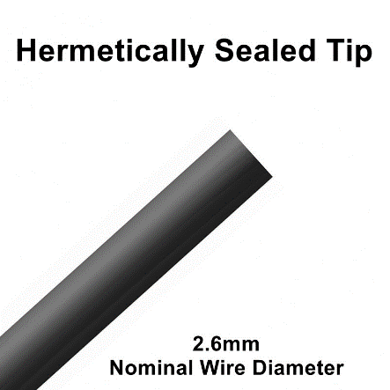

Labfacility are the UK’s leading manufacturer of Temperature Sensors, Thermocouple Connectors and associated Temperature Instrumentation and stockists of Thermocouple Cables. The Company has been trading since 1971 and is ISO 9001 accredited.

* Pt100 class A 4 wire resistance thermometer
* Hermetically sealed airtight tip
* Waterproof & suitable for insertion into liquids
* Oil & Chemical resistant PFA insulation
* For use in temperatures ranging from -30 to +260 Degree C
* Electrically insulated tip tested to 1.0Kv as standard (can be tested at higher voltages)
* 4 wire flexible 7/0.2mm stranded conductors (24AWG) with 75mm tails
* 2.6mm nominal wire diameter

An IP67 wire RTD sensor that is hermetically sealed for use in corrosive or wet environments.

**Specifications**

|  |  |
| --- | --- |
| **General Description** | An IP67 wire RTD sensor that is hermetically sealed for use in corrosive or wet environments |
| **Sensor Type** | Hermetically sealed Pt100 class A 4 wire resistance thermometer |
| **Cable Length** | 2m |
| **Cable Type** | 4 wire flexible 7/0.2mm stranded conductors (24AWG) with 75mm tails |
| **Core / Strands** | 7/0.2mm (24AWG) |
| **Termination Type** | 75mm Bare Tails |
| **Max. Temperature** | +260°C |
| **Min. Temperature** | -30°C |
| **Tolerance** | Class A |
| **Standards Met** | IP67 |
| **Important Information** | Pressure tested at 40 PSI as standard |

**Ordering Information**

|  |  |  |  |  |
| --- | --- | --- | --- | --- |
| **Type** | **Length** | **Cable Size** | **Termination** | **Order Number** |
| Pt100 | 2m | 7/0.2mm | Bare Wire | XE-6381-001 |