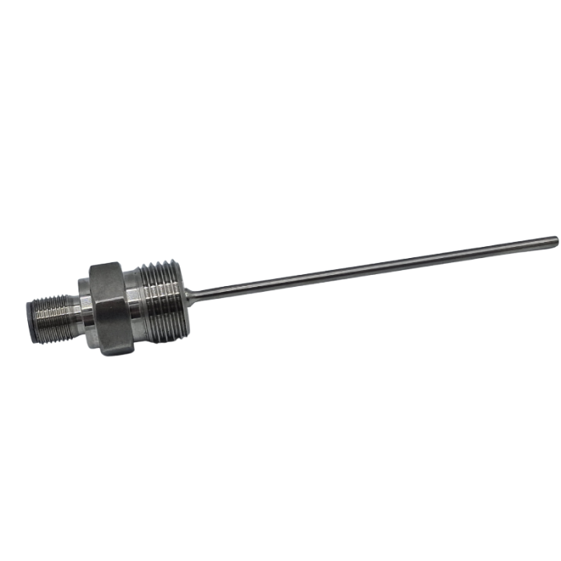

**M12 RTD With 1/2" NPT Process Fitting 3x200mm**

XE-7234-001

Labfacility are the UK’s leading manufacturer of Temperature Sensors, Thermocouple Connectors and associated Temperature Instrumentation and stockists of Thermocouple Cables. The Company has been trading since 1971 and is ISO 9001 accredited.

An industrial automation temperature sensor with a Pt100 class A 4 wire resistance thermometer detector (RTD) with a measuring range of -75 to +250°C.

The Sensor features an industry standard 4 pin M12 A coded instrument connection, suitable for new industrial process control & automation applications and field replacement of sensors.

* Pt100 RTD class A 4 wire resistance thermometer as per IEC 751
* Sensor temperature rating -75°C to +250°C
* 4 pin M12 A coded instrument connection
* For use with M12 female connectors & extension cables.

**Typical Applications**

* Automation Applications
* Field Replacement of Sensors
* Industrial Process Control
* Pharmaceuticals & Chemical Plants

|  |  |
| --- | --- |
| **General Description** | Pt100 RTD Class A 4-wire resistance thermometer as per IEC 751 |
| **Sensor Type** | Pt100 |
| **Sheath Material** | 316 Stainless Steel |
| **Termination Type** | M12 Male |
| **Sheath Length (mm)** | 200mm standard length |
| **Sheath Diameter (mm)** | 3mm |
| **Process Connection options** | 1/2” NPT |
| **Max. Temperature** | 250°C |
| **Min. Temperature** | -75°C |
| **Number of Wires** | 4 wire |

**Ordering Information**

|  |  |  |  |
| --- | --- | --- | --- |
| **Type** | **Size** | **Process Connection** | **Order Number** |
| Pt100 | 3mm x 200mm | 1/2” NPT | XE-7234-001 |